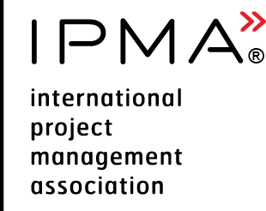 | Executive Summary Report  for IPMA Level A, B, C candidate,  PROJECT MANAGEMENT | 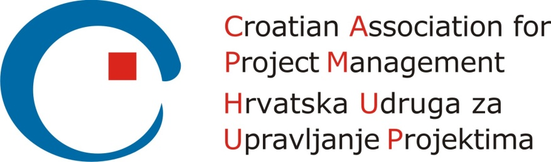  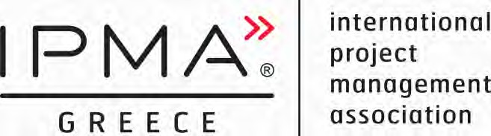

Please consider the environment before printing this document

Version control
Version and date of CVMB approval | Date | Valid until
Version 1.0 | 11.10.2016 | N/A

Configuration control
Date | Version | Section | Change
29.04.2016 | 0.1 | All | - Initial draft
29.05.2016 | 0.2 | All | - Changes after comments
29.06.2016 | 0.3 | All | - Jorunn’s and Dalibor’s comments incorporated
08.07.2016 | 0.3 JW | All | - Comments from Jorunn
02.08.2016 | 0.4 | All | - Incorporated comments from CVMB  - Changed name of document  - Adopted for levels A, B, C
11.10.2016 | 0.9 | All | - Proposed Version by Project Team
11.10.2016 | 1.0 | All | - Endorsed by CVMB for CB use and modification

Purpose
The purpose of this document is to provide directions how to prepare executive summary report for IPMA level A, B, C candidate working in project management.
Candidate Name |  |  | Insert link to your CV
Level Applied for (check one) | IPMA Level A | IPMA Level B |  | IPMA Level C
Description of employer’s organisation
Organisation name: | Enter organisation name here
Number of employees | < 250 | 250 – 5000 | > 5000
Main line of organisation’s industry | E.g. software development, banking
Role of applicant within employer’s organisation
An organisation chart with applicant position identified
Area of responsibility

An overview of the project management processes/ procedures used

Summary for all projects
Name of the project | Project start date | Project finish date | Duration, months | Score of complexity
Project #1
Project #2
Project #3
Add more lines if applicable

Summary of the project #1
Goal of the project and main deliverables
Time schedule and phases | Project start/finish dates: xx.xx.xxxx - xx.xx.xxxx  List all phases covered:
Management effort | Total no of menmonths of management/ total number of menmonths of execution
Total budget
Resources available | Personnel :  - No of persons total (peak) in the project  - No of persons reporting to you
Contractors | - No of contractors  - No of subcontractors
Stakeholders | Relationship with internal and external stakeholders
Project Control methods and documents used (tick off) | Project assignment  Work Breakdown Structure  Milestone schedule  Stakeholder management  Risk and opportunity management  Resource plan  Cost and finance plan  Earned Value report  Progress report  Others (list)
Description of project challenges | Describe how you have managed project and how you met the complexity criteria. You can use the STAR approach (Situation, Task, Action, Result) in order to structure the report.  - Situation/challenge  - Effort to deal with it  - Outcome  - Reference to CEs  You can include the links to the information in complexity criteria form

Please copy and fill in relevant parts of this report according your needs to cover your experience.

